Amsterdam Is Embracing a Radical New Economic Theory to Help Save the Environment.
Could It Also Replace Capitalism?
Time.com January 22, 2021 3:11 PM EST
One evening in December, after a long day working from home, Jennifer Drouin, 30, headed out to buy groceries in central Amsterdam. Once inside, she noticed new price tags. The label by the zucchini said they cost a little more than normal: 6¢ extra per kilo for their carbon footprint, 5¢ for the toll the farming takes on the land, and 4¢ to fairly pay workers. “There are all these extra costs to our daily life that normally no one would pay for, or even be aware of,” she says.
The so-called true-price initiative, operating in the store since late 2020, is one of dozens of schemes that Amsterdammers have introduced in recent months as they reassess the impact of the existing economic system. By some accounts, that system, capitalism, has its origins just a mile from the grocery store. In 1602, in a house on a narrow alley, a merchant began selling shares in the nascent Dutch East India Company. In doing so, he paved the way for the creation of the first stock exchange—and the capitalist global economy that has transformed life on earth. “Now I think we’re one of the first cities in a while to start questioning this system,” Drouin says. “Is it actually making us healthy and happy? What do we want? Is it really just economic growth?”
In April 2020, during the first wave of COVID-19, Amsterdam’s city government announced it would recover from the crisis, and avoid future ones, by embracing the theory of “doughnut economics.” Laid out by British economist Kate Raworth in a 2017 book, the theory argues that 20th century economic thinking is not equipped to deal with the 21st century reality of a planet teetering on the edge of climate breakdown. Instead of equating a growing GDP with a successful society, our goal should be to fit all of human life into what Raworth calls the “sweet spot” between the “social foundation,” where everyone has what they need to live a good life, and the “environmental ceiling.” By and large, people in rich countries are living above the environmental ceiling. Those in poorer countries often fall below the social foundation. The space in between: that’s the doughnut.
Amsterdam’s ambition is to bring all 872,000 residents inside the doughnut, ensuring everyone has access to a good quality of life, but without putting more pressure on the planet than is sustainable. Guided by Raworth’s organization, the Doughnut Economics Action Lab (DEAL), the city is introducing massive infrastructure projects, employment schemes and new policies for government contracts to that end. Meanwhile, some 400 local people and organizations have set up a network called the Amsterdam Doughnut Coalition—managed by Drouin— to run their own programs at a grassroots level.
It’s the first time a major city has attempted to put doughnut theory into action on a local level, but Amsterdam is not alone. Raworth says DEAL has received an avalanche of requests from municipal leaders and others seeking to build more resilient societies in the aftermath of COVID-19. Copenhagen’s city council majority decided to follow Amsterdam’s example in June, as did the Brussels region and the small city of Dunedin, New Zealand, in September, and Nanaimo, British Columbia, in December. In the U.S., Portland, Ore., is preparing to roll out its own version of the doughnut, and Austin may be close behind. The theory has won Raworth some high-profile fans; in November, Pope Francis endorsed her “fresh thinking,” while celebrated British naturalist Sir David Attenborough dedicated a chapter to the doughnut in his latest book, A Life on Our Planet, calling it “our species’ compass for the journey” to a sustainable future.
Now, Amsterdam is grappling with what the doughnut would look like on the ground. Marieke van Doorninck, the deputy mayor for sustainability and urban planning, says the pandemic added urgency that helped the city get behind a bold new strategy. “Kate had already told us what to do. COVID showed us the way to do it,” she says. “I think in the darkest times, it’s easiest to imagine another world.”
In 1990, Raworth, now 50, arrived at Oxford University to study economics. She quickly became frustrated by the content of the lectures, she recalls over Zoom from her home office in Oxford, where she now teaches. She was learning about ideas from decades and sometimes centuries ago: supply and demand, efficiency, rationality and economic growth as the ultimate goal. “The concepts of the 20th century emerged from an era in which humanity saw itself as separated from the web of life,” Raworth says. In this worldview, she adds, environmental issues are relegated to what economists call “externalities.” “It’s just an ultimate absurdity that in the 21st century, when we know we are witnessing the death of the living world unless we utterly transform the way we live, that death of the living world is called ‘an environmental externality.’”
Almost two decades after she left university, as the world was reeling from the 2008 financial crash, Raworth struck upon an alternative to the economics she had been taught. She had gone to work in the charity sector and in 2010, sitting in the open-plan office of the antipoverty nonprofit Oxfam in Oxford, she came across a diagram. A group of scientists studying the conditions that make life on earth possible had identified nine “planetary boundaries” that would threaten humans’ ability to survive if crossed, like the acidification of the oceans. Inside these boundaries, a circle colored in green showed the safe place for humans.
But if there’s an ecological overshoot for the planet, she thought, there’s also the opposite: shortfalls creating deprivation for humanity. “Kids not in school, not getting decent health care, people facing famine in the Sahel,” she says. “And so I drew a circle within their circle, and it looked like a doughnut.”
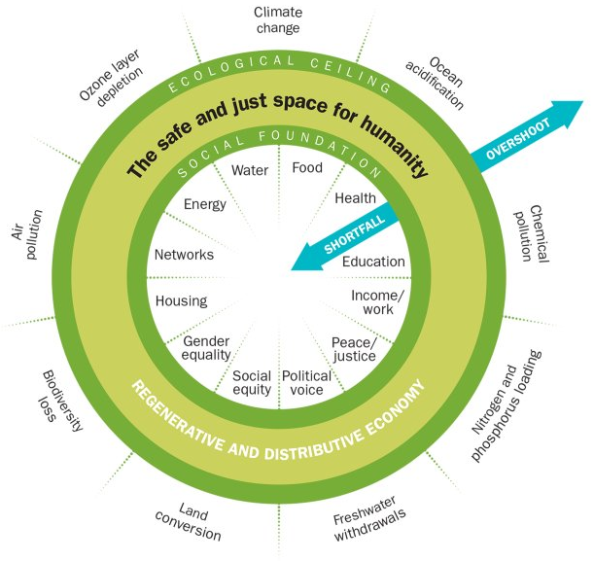

Inner Ring: Twelve essentials of life that no one in society should be deprived of;
Outer Ring: Nine ecological limits of earth’s life-supporting systems that humanity must not collectively overshoot;
Sweet Spot: The space both environmentally safe and socially just where humanity can thrive
Lon Tweeten for TIME
Raworth published her theory of the doughnut as a paper in 2012 and later as a 2017 book, which has since been translated into 20 languages. The theory doesn’t lay out specific policies or goals for countries. It requires stakeholders to decide what benchmarks would bring them inside the doughnut—emission limits, for example, or an end to homelessness. The process of setting those benchmarks is the first step to becoming a doughnut economy, she says.
Raworth argues that the goal of getting “into the doughnut” should replace governments’ and economists’ pursuit of never-ending GDP growth. Not only is the primacy of GDP overinflated when we now have many other data sets to measure economic and social well-being, she says, but also, endless growth powered by natural resources and fossil fuels will inevitably push the earth beyond its limits. “When we think in terms of health, and we think of something that tries to grow endlessly within our bodies, we recognize that immediately: that would be a cancer.”
The doughnut can seem abstract, and it has attracted criticism. Some conservatives say the doughnut model can’t compete with capitalism’s proven ability to lift millions out of poverty. Some critics on the left say the doughnut’s apolitical nature means it will fail to tackle ideology and political structures that prevent climate action.
Cities offer a good opportunity to prove that the doughnut can actually work in practice. In 2019, C40, a network of 97 cities focused on climate action, asked Raworth to create reports on three of its members—Amsterdam, Philadelphia and Portland—showing how far they were from living inside the doughnut. Inspired by the process, Amsterdam decided to run with it. The city drew up a “circular strategy” combining the doughnut’s goals with the principles of a “circular economy,” which reduces, reuses and recycles materials across consumer goods, building materials and food. Policies aim to protect the environment and natural resources, reduce social exclusion and guarantee good living standards for all. Van Doorninck, the deputy mayor, says the doughnut was a revelation. “I was brought up in Thatcher times, in Reagan times, with the idea that there’s no alternative to our economic model,” she says. “Reading the doughnut was like, Eureka! There is an alternative! Economics is a social science, not a natural one. It’s invented by people, and it can be changed by people.”

The new, doughnut-shaped world Amsterdam wants to build is coming into view on the southeastern side of the city. Rising almost 15 ft. out of placid waters of Lake IJssel lies the city’s latest flagship construction project, Strandeiland (Beach Island). Part of IJburg, an archipelago of six new islands built by city contractors, Beach Island was reclaimed from the waters with sand carried by boats run on low-emission fuel. The foundations were laid using processes that don’t hurt local wildlife or expose future residents to sea-level rise. Its future neighborhood is designed to produce zero emissions and to prioritize social housing and access to nature. Beach Island embodies Amsterdam’s new priority: balance, says project manager Alfons Oude Ophuis. “Twenty years ago, everything in the city was focused on production of houses as quickly as possible. It’s still important, but now we take more time to do the right thing.”
Lianne Hulsebosch, IJburg’s sustainability adviser, says the doughnut has shaped the mindset of the team, meaning Beach Island and its future neighbor Buiteneiland are more focused on sustainability than the first stage of IJburg, completed around 2012. “It’s not that every day-to-day city project has to start with the doughnut, but the model is really part of our DNA now,” she says. “You notice in the conversations that we have with colleagues. We’re doing things that 10 years ago we wouldn’t have done because we are valuing things differently.”
The city has introduced standards for sustainability and circular use of materials for contractors in all city-owned buildings. Anyone wanting to build on Beach Island, for example, will need to provide a “materials passport” for their buildings, so whenever they are taken down, the city can reuse the parts.
On the mainland, the pandemic has inspired projects guided by the doughnut’s ethos. When the Netherlands went into lockdown in March, the city realized that thousands of residents didn’t have access to computers that would become increasingly necessary to socialize and take part in society. Rather than buy new devices—which would have been expensive and eventually contribute to the rising problem of e-waste—the city arranged collections of old and broken laptops from residents who could spare them, hired a firm to refurbish them and distributed 3,500 of them to those in need. “It’s a small thing, but to me it’s pure doughnut,” says van Doorninck.
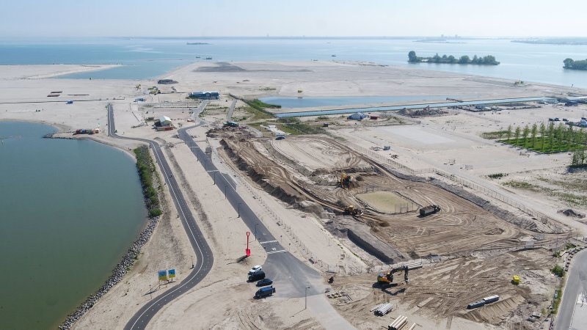
The city says the Beach Island development will prioritize balancing the needs of humans and nature; Gemeente Amsterdam
The local government is also pushing the private sector to do its part, starting with the thriving but ecologically harmful fashion industry. Amsterdam claims to have the highest concentration of denim brands in the world, and that the average resident owns five pairs of jeans. But denim is one of the most resource-intensive fabrics in the world, with each pair of jeans requiring thousands of gallons of water and the use of polluting chemicals.
In October, textile suppliers, jeans brands and other links in the denim supply chain signed the “Denim Deal,” agreeing to work together to produce 3 billion garments that include 20% recycled materials by 2023—no small feat given the treatments the fabric undergoes and the mix of materials incorporated into a pair of jeans. The city will organize collections of old denim from Amsterdam residents and eventually create a shared repair shop for the brands, where people can get their jeans fixed rather than throwing them away. “Without that government support and the pressure on the industry, it will not change. Most companies need a push,” says Hans Bon of denim supplier Wieland Textiles.
Of course, many in the city were working on sustainability, social issues or ways to make life better in developing countries before the city embraced the doughnut. But Drouin, manager of Amsterdam’s volunteer coalition, says the concept has forced a more fundamental reckoning with the city’s way of life. “It has really changed people’s mindset, because you can see all the problems in one picture. It’s like a harsh mirror on the world that you face.”
Doughnut economics may be on the rise in Amsterdam, a relatively wealthy city with a famously liberal outlook, in a democratic country with a robust state. But advocates of the theory face a tough road to effectively replace capitalism. In Nanaimo, Canada, a city councillor who opposed the adoption of the model in December called it “a very left-wing philosophy which basically says that business is bad, growth is bad, development’s bad.”
In fact, the doughnut model doesn’t proscribe all economic growth or development. In her book, Raworth acknowledges that for low- and middle-income countries to climb above the doughnut’s social foundation, “significant GDP growth is very much needed.” But that economic growth needs to be viewed as a means to reach social goals within ecological limits, she says, and not as an indicator of success in itself, or a goal for rich countries. In a doughnut world, the economy would sometimes be growing and sometimes shrinking.
Still, some economists are skeptical of the idealism. In his 2018 review of Raworth’s book, Branko Milanovic, a scholar at CUNY’s Stone Center on Socio-Economic Inequality, says for the doughnut to take off, humans would need to “magically” become “indifferent to how well we do compared to others, and not really care about wealth and income.”
In cities that are grappling with the immediate social and economic effects of COVID-19, though, the doughnut framework is proving appealing, says Joshua Alpert, the Portland-based director of special projects at C40. “All of our mayors are working on this question: How do we rebuild our cities post-COVID? Well, the first place to start is with the doughnut.” Alpert says they have had “a lot of buy-in” from city leaders. “Because it’s framed as a first step, I think it’s been easier for mayors to say this is a natural progression that is going to help us actually move out of COVID in a much better way.”
Drouin says communities in Amsterdam also have helped drive the change. “If you start something and you can make it visible, and prove that you or your neighborhood is benefiting, then your city will wake up and say we need to support them.” In her own neighborhood, she says, residents began using parking spaces to hold dinners with their neighbors during summer, and eventually persuaded the municipality to convert many into community gardens.
Citizen-led groups focused on the doughnut that are forming in places including São Paulo, Berlin, Kuala Lumpur and California bring the potential to transform their own areas from the bottom up. “It’s powerful when you have peers inspiring peers to act: a teacher inspires another teacher, or a schoolchild inspires their class, a mayor inspires another mayor,” Raworth says. “I’m really convinced that’s the way things are going to happen if we’re going to get the transformation that we need this decade.”
COVID-19 has the potential to massively accelerate that transformation, if governments use economic-stimulus packages to favor industries that lead us toward a more sustainable economy, and phase out those that don’t. Raworth cites Milton Friedman—the diehard free-market 20th century economist—who famously said that “when [a] crisis occurs, the actions that are taken depend on the ideas that are lying around.” In July, Raworth’s DEAL group published the methodology it used to produce the “city portrait” that is guiding Amsterdam’s embrace of the doughnut, making it available for any local government to use. “This is the crisis,” she says. “We’ve made sure our ideas are lying around.”
This appears in the February 1, 2021 issue of TIME.

